Philosophy of the East and the West

Summer 2022

Kevin Meng

Schedule: June 27th to July 9th, Monday to Saturday, 10 to 12am

**Course Objectives:**

-To improve our abilities in academic writing through regular writing exercises, peer feedback, and individual consultations with Kevin

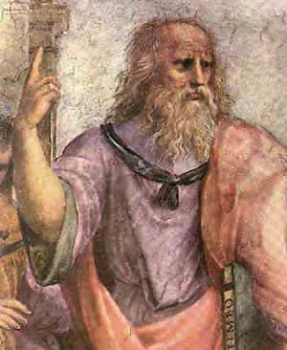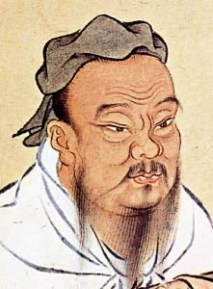

-To practice critical thinking skills through discussion, socratic seminars and presentations.

-To experience the college-style class room and rigorous final paper

-To familiarize ourselves with major philosophers and schools of philosophical thought in Pre-Qin China and ancient Greece.

**Course description:**

Today’s students pride themselves in their open-mindedness and diversity. As international students in China and Chinese seeking to study abroad, they are the bridge between cultures, peoples, and societies, a bridge between the East and the West in a time when the two seems to move closer together while simultaneously growing ever-more apart. We live in a time of rapid change, whether that is manifested through the rise of social media or the advent of global pandemics. To make sense of all that’s happening around us—the good, the bad, and the ugly—I ask that we return to the classics. For millennia, the words of great philosophers of the East and the West have informed how their respective society, thinks, acts, and functions. We study these texts as lenses to aid our understanding of the global issues of today, but also as a source of wisdom and inspiration to guide us in life. This course provides a broad overview of Chinese thinkers of the Pre-Qin era, with a focus on Ruism and Daoism, during the first week, and moves on to the dense works of Plato and Aristotle in ancient Greece. Throughout this course, students will be challenged to think, discuss, and most importantly, write down their ideas into powerful, coherent arguments. Without further ado, let the philosophizing begin!

**Course Materials:**

Eastern Philosophy:

-Readings *in Classical Chinese Philosophy* (Philip Ivanhoe and Bryan VanNorden)

-*The Analects* (Confucius)

-Mencius (Mencius)

-*Great Learning* (Zengzi)

-*Xunzi* (Xunzi)

-*Dao De Jing* (Laozi)

-*Zhuangzi* (Zhuangzi)

Western Philosophy:

-*Republic* (Plato)

-*Apology* (Plato)

-*Crito* (Plato)

-*Phaedo* (Plato)

-*Nicomachean Ethics* (Aristotle)

-*Politics* (Aristotle)

**Course Evaluation:**

Class participation: 40%

Students are expected to participate in class discussions, raise thoughtful questions and challenge each other’s arguments. As long as the student is demonstrating agency and thoughtfulness, they will receive the full class participation grade.

Individual presentation: 20%

Each student will have the opportunity to present in front of the class in a 10-15 min presentation about a particular idea in the course material (Eg. Plato’s allegory of the cave). The presentation will be graded on how well it summarizes the original text, the quality of analysis, the student’s own insights and evaluation, and how clearly the student speaks. The presentation takes place throughout the 2 weeks of this course.

Final Paper: 20%

The final paper is a 6-8 page (double spaced) analytical paper that requires the student to compare an aspect or idea of the materials covered in the Eastern philosophy component of the course to that of the Western philosophy component. Precise prompts can be decided by students themselves. The final paper will be graded on the following factors: stylistic quality of the student’s writing, technical command of the course material, and forcefulness of the student’s thesis and success in logically arguing that thesis in the paper. The paper is due the weekend of the end of this course.